Answer 2
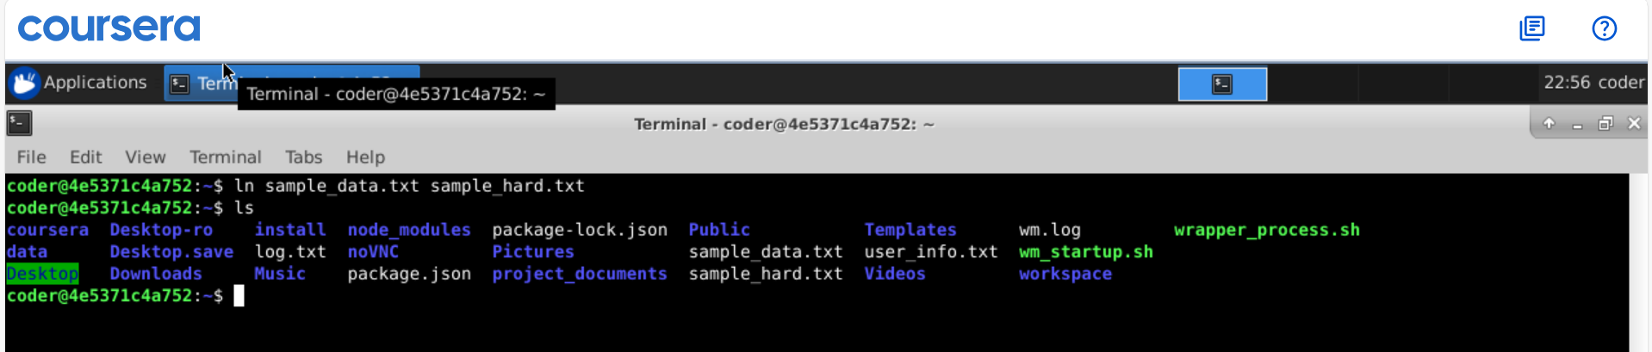
Explanation: By using ln command we get a hardlink as desires. It would by provide source file first and desired name for hardline next.

